CO5-AT2 SHORT ANSWERS TEST
NAME: S.MAHALAKSHMI
REG NO: 192524372
COURSE:DATA STRUCTURE
COURSE CODE: CSA0311

Q1:

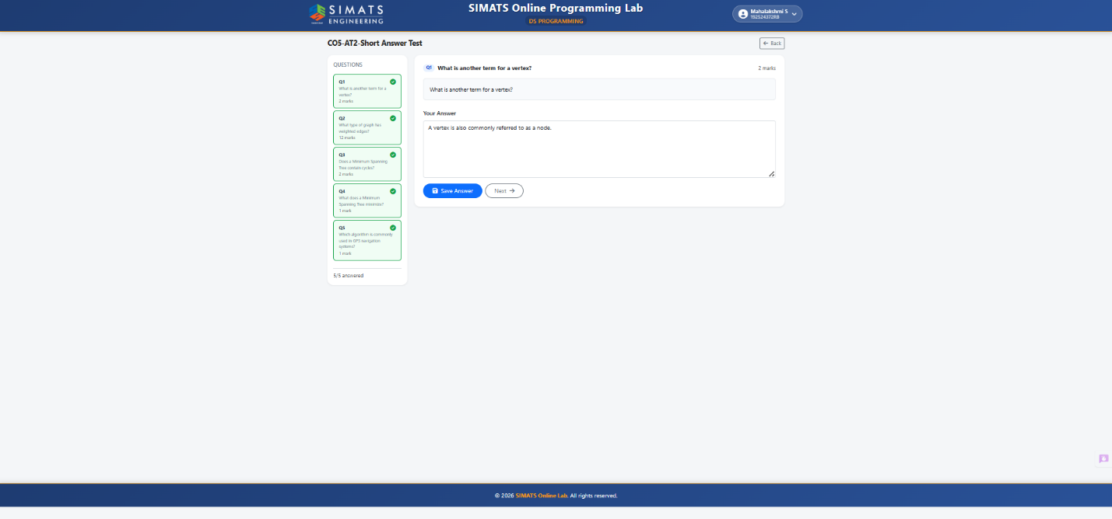

Q2:

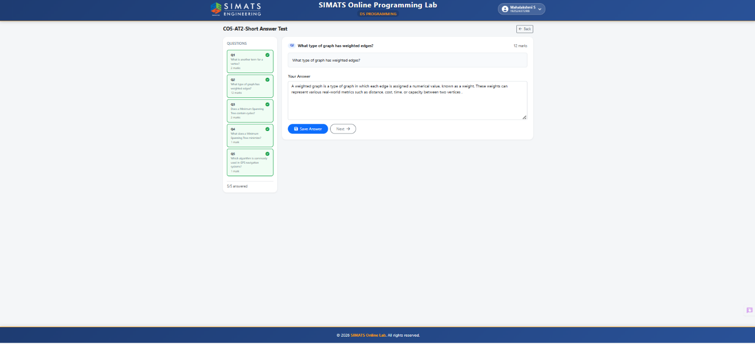

Q3:

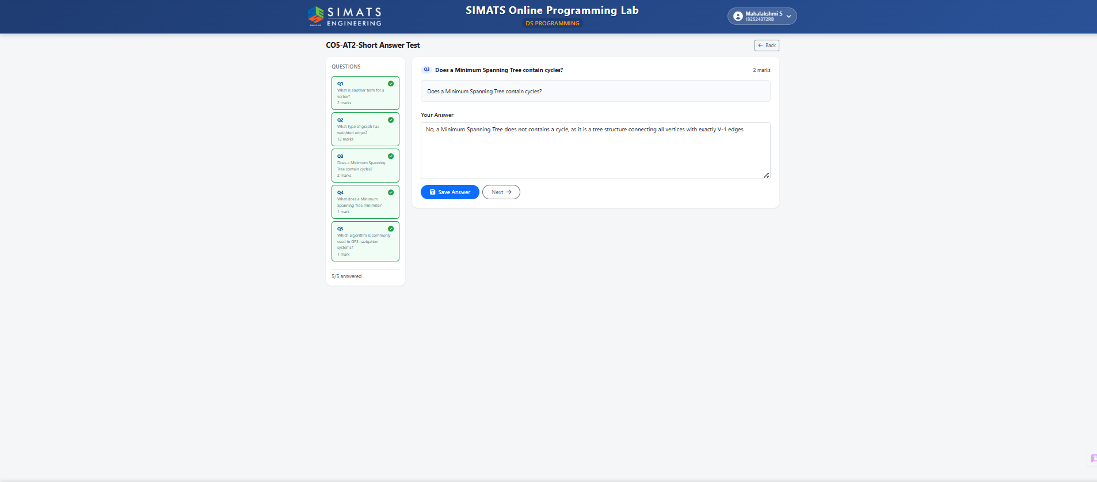

Q4:
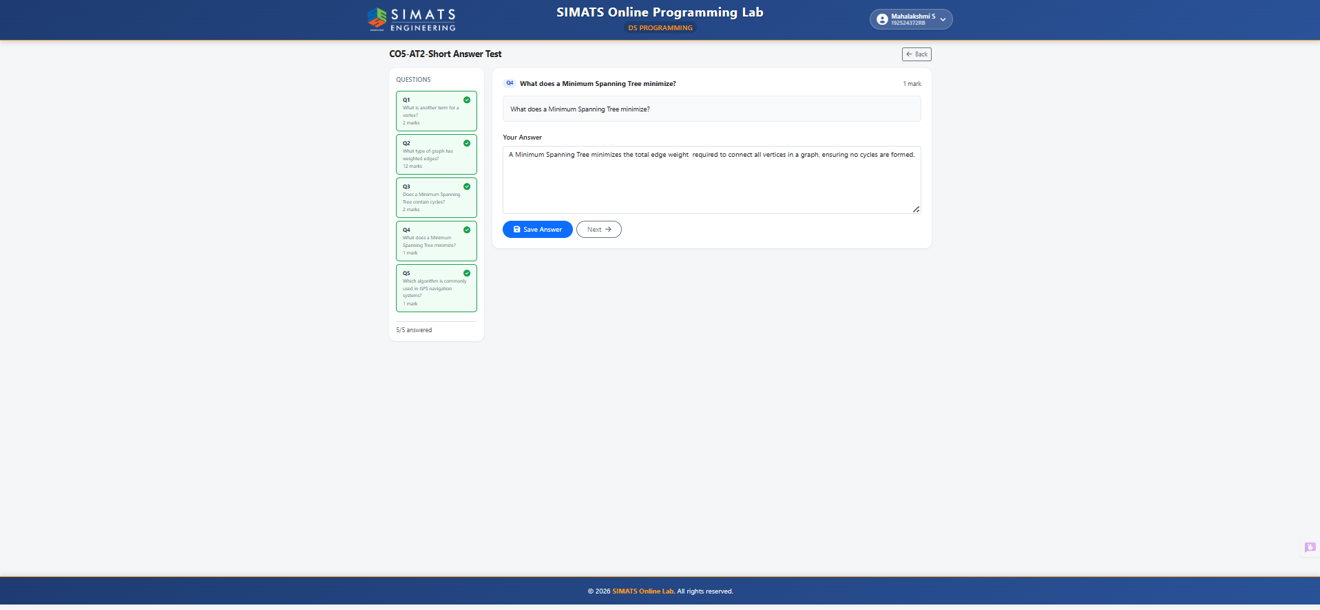

Q5:
